**K LEF deemed to be University**

**Green Fields, Vaddeswaram, Guntur (Dt) :: 522502**

**Department of Computer Science Engineering**

**Project Based Lab Report**

**PLATFORM BASED DEVELOPMENT**

**15 CS 3113**



**Submitted by**

160030154 B.Reshma

**Under Guidance of**

Your FACULTY

**III Year Engineering Course Work**

**2018-19**

DECLARATION

We declare that the project work entitled “**FACULTY FEEDBACK** “was carried out by us during 2017-18, and this work is not the same as that of any other and has not been submitted for award of any other degree/diploma

Place: Signature of the Student

Date:



**K.L.E. F deemed to be UNIVERSITY**

**Green fields,Vaddeswaram,Guntur Dist**.

CERTIFICATE

This is certify that this project work entitled “**FACULTY FEEDBACK**” by is a bonafide work carried out by them in Department of Mechanical Engineering.

Project supervisor Head of the Department

ACKNOWLEDGEMENT

We express my sincere gratitude to **Dr.M.S.R.Prasad** sir for encouraging and guiding us to

undertake this project work.

We express my deep sense of gratitude to**Dr.M.S.R.Prasad** sir and our beloved course lecturers of department for their encouragement.

Place:

Date:

|  |  |  |
| --- | --- | --- |
| **S.NO** | **CONTENTS** | **PAGE.NO** |
| **1** | ABSTRACT | 2 |
| **2** | INTRODUCTION | 3 |
| **3** | FUNCTIONAL REQUIREMENT | 5 |
| **4** | NON FUNCTIONAL REQUIREMENT | 6 |
| **5** | MODULE EXPLANATION | 7 |
| **6** | SOURCE CODE | 8 |
| **7** | OUTPUTS | 42 |
| **8** | CONCLUSION | 48 |
| **9** | BIBLIOGRAPHY | 48 |

**Introduction to technology used in this project (Android):**

Android delivers a complete set of software for mobile devices:

• Operating System

• Middleware

• Key mobile applications

• Open

• Breaking down Application Boundaries

• Fast & Easy Application Development

Industry

• Software stack opensourced under Apache 2.0 license

• Source available after first handsets ship

• Anyone will be able to build a system image

Users

• Users have control of their experience

• They control what gets installed

• They choose the defaults

Developer

• Don not need permission to ship an application

• No hidden or privileged framework APIs

• Can integrate, extend and replace existing components

**LINUX KERNEL**

• Android OS is built on top of the Linux 2.6 Kernel

– Linux Core functionality

• Memory management

• Process management

• Networking

• Security settings

– Hardware drivers

**Android Runtime**

What is Android? > Android Architecture

• Core Libraries

– Provides the functionality of the JAVA Programming Language

• Dalvik VM

– A type of Java Virtual Machine

– Register based (not stack machine like JVM)

– Optimization for low memory requirements

– Executes .dex (Dalvik-Executable) files instead of .class

– DX tool converts classes to .dex format Each Android application:

• runs on its own Process

• runs on its own Instance of Dalvik VM

• is assigned its own Linux user ID

**Application Framework**

What is Android? > Android Architecture

• The blocks that our applications directly interact with.

• Important blocks: – Activity Manager: Manages the activity life cycle of applications

– Content Providers: Manage the data sharing between applications

– Telephony Manager: Manages all voice calls. We use telephony manager if we want to access voice calls in our application.

– Location Manager: Location management, using GPS or cell tower

– Resource Manager: Manage the various types of resources we use in our Application

**Applications**

• This is where our applications are placed.

• Some pre-installed applications:

– SMS client app

– Dialer

– Web browser

– Contact manager

• As developers, we are able to write an app which replaces any existing system app.

**Details:-**

• Design goals

– Open Source

– High flexibility

– High data accessibility

– Rapid development (XML, Java)

• Used Languages

– App: Java

– Framework: Java

– Libraries: C/C++

– OS & Drivers: C

**ABSTRACT**

We have developed Student Staff Feedback System to provide feedback in an easy and quick manner to the college principal and Hod’s. So we call it as Student Staff Feedback System which delivers via the student staff interface as online system which acting as a Service Provider By using this technology we can make fast feedback about the staff by students on time to head of departments as they referred in online system. This project has four kinds of users Student, Staff, Hod’s, and Principal. The student can give feedback in online system provided by college staff. First of staff can prepare questions & add, update these questions to the online system. After that it was viewed by the students and can give feedback about the lecturers.

This feedback report was checked by the Hod’s. He can view grades and view the grades obtained to the lecturers and give this report to the principal and he give counseling to the college staff.

Online student feedback system is the web based feedback collecting system from the students and provides the automatic generation of a feedback which is given by students. We have developed student feedback system to provide feedback in a quick and easy manner to the particular department. So we called it a student’s feedback system which delivers via the student staff interface as online system which acting as a service provider. By using this technology we can give feedback in online system as fast as compare to the existing paper feedback system.

The existing system carries more time to do a piece of work for this reason the online system feedback is implemented. Students will fill online feedback using a standard form. In this project security is also maintain that is the result of feedback is only visible to authentic user

The main features of this project are:

1. LOGIN
2. SUBJECT SEKECTION.
3. STUDENT FEEDBACK

OBJECTIVES:

1. Decision making power is provided by this system. 2) Accurate result can be obtained. 3) This system makes Selection process more effective 4) To increase efficiency proposed system is depend on classification method. 5) Proposed system is used to reduce confusion at the time of processing feedback.

**INTRODUCTION:-**

Online student feedback system is the web based feedback collecting system from the students and provides the automatic generation of a feedback which is given by students. We have developed student feedback system to provide feedback in a quick and easy manner to the particular department. We have developed Student Staff Feedback System to provide feedback in an easy and quick manner to the college principal and Hod’s. So we call it as Student Staff Feedback System which delivers via the student staff interface as online system which acting as a Service Provider. So we called it a student’s feedback system which delivers via the student staff interface as online system which acting as a service provider. By using this technology we can make fast feedback about the staff by students on time to head of departments as they referred in online system. By using this technology we can give feedback in online system as fast as compare to the existing paper feedback system.

This project has four kinds of users Student, Staff, Hod’s, and Principal. The student can give feedback in online system provided by college staff. The existing system carries more time to do a piece of work for this reason the online system feedback is implemented. First of staff can prepare questions & add, update these questions to the online system.

After that it was viewed by the students and can give feedback about the lecturers.Students will fill online feedback using a standard form. In this project security is also maintain that is the result of feedback is only visible to authentic user. This feedback report was checked by the Hod’s. He can view grades and view the grades obtained to the lecturers and give this report to the principal and he give counseling to the college staff

.

**MODULES OF STUDENT FEEDBACK MANAGEMENT SYSTEM**  
  
The proposed system consists of four modules:  
**Student :**  
Student can give the feedback about the lecturers on the scale of five. Students can give feed back about the lecturer based on interaction of lecturer in the class room with students. Here we shared complete list of student projects that we shared in this page. Screenshot of Employee and Payroll System; Project SRS. IEEE Standard SRS. According to that, students can give feedback as per the given grades.  
**Staff:**  
The feedback given by the students can be viewed by the staff and improve their performance in teaching and other aspects

**Head Of Departments :**  
These feedback reports were checked by the Hod’s. He can view overall grades and view the grades obtained to the lecturers and give this report to the principal and he can give counseling to the college staff  
**Principal :**

Finally, report was referred by the principal and give suggestions to lecturers to improve their teaching. These are the four modules present in the project so we have developed these things in very easy and clearly understandable way. So, by seen above description the proposed system having many advantages as compared to the existing system.

🡪**PLATFORM REQUIREMENTS:**

|  |  |  |
| --- | --- | --- |
| **Hardware/Software** | **Hardware / Software element** | **Specification /version** |
| **Hardware** | Processor | Intel multi-core i5 |
| RAM | 4 GB |
| Hard Disk | 1 TB |
| **Software** | OS | Windows 10 |
| Java Command Prompt and Notepad |  |

🡪**SOFTWARE REQUIREMENTS SPECIFICATION**

|  |  |
| --- | --- |
| **Serial Number** | **Name of the Module** |
|  | LOGIN |
|  | SUBJECT SELECTION |
|  | STUDENT FEEDBACK |
|  | FACULTY |

**NON FUNCTIONAL REQUIREMENTS**

**EXCEPTION HANDLING:**

An exception (or exceptional event) is a problem that arises during the execution of a program.When an Exception occurs the normal flow of the program is disrupted and the program/Application terminates abnormally, which is not recommended, therefore,these exceptions are to be handled.

**BUFFERED READER:**

The Java.io.BufferedReader class reads text from a character-input stream, buffering characters so as to provide for the efficient reading of characters, arrays, and lines.Following are the important points about BufferedReader − The buffer size may be specified, or the default size may be used.

**FILE READER:**

The FileReader object lets web applications asynchronously read the contents of files (or raw data buffers) stored on the user's computer, using File or Blob objects to specify the file or data to read.

**FILE WRITTER:**

Java File Writer class is used to write character-oriented data to a file. It is character-oriented class which is used for file handling in java. Unlike FileInputStream class, you don't need to convert string into byte array because it provides method to write string directly.

**FORMATTER:**

The **java.util.Formatter** class provides support for layout justification and alignment, common formats for numeric, string, and date/time data, and locale-specific output.Following are the important points about Formatter:

Formatters are not necessarily safe for multithreaded access.Thread safety is optional and is the responsibility of users of methods in this class.

**STATIC KEYWORD:**

All instances share the same copy of the variable. A class variable can be accessed directly with the class, without the need to create a instance.

**SOURCE CODE:**

FiLe:MainActivity.java

**package** com.example.facultyfeedback;  
  
**import** android.content.Intent;  
**import** android.os.Bundle;  
**import** android.support.v7.app.AppCompatActivity;  
**import** android.view.MenuItem;  
**import** android.view.View;  
**import** android.widget.EditText;  
**import** android.widget.Toast;  
  
  
  
**public class** MainActivity **extends** AppCompatActivity {  
 EditText **txt1**;  
 EditText **txt2**;  
 MyDBHelper **myDBHelper**;  
 @Override  
 **protected void** onCreate(Bundle savedInstanceState) {  
 **super**.onCreate(savedInstanceState);  
 setContentView(R.layout.***activity_main***);  
 **txt1**=findViewById(R.id.***editText***);  
 **txt2**=findViewById(R.id.***editText2***);  
 **myDBHelper** = **new** MyDBHelper(**this**);  
 **myDBHelper**.insertstudentrec(**"CSE"**,**"B.Tech"**,**"Y16"**,**"2"**,**"EVEN"**,8,160030001,**"Akhila"**,**"klef30001"**);  
 **myDBHelper**.insertstudentrec(**"CSE"**,**"B.Tech"**,**"Y16"**,**"2"**,**"EVEN"**,8,160030002,**"Alekya"**,**"klef30002"**);  
 **myDBHelper**.insertstudentrec(**"CSE"**,**"B.Tech"**,**"Y16"**,**"2"**,**"EVEN"**,8,160030003,**"Akarsh"**,**"klef30003"**);  
 **myDBHelper**.insertstudentrec(**"CSE"**,**"B.Tech"**,**"Y16"**,**"2"**,**"EVEN"**,8,160030004,**"Akansha"**,**"klef30004"**);  
 **myDBHelper**.insertstudentrec(**"CSE"**,**"B.Tech"**,**"Y16"**,**"2"**,**"EVEN"**,8,160030005,**"Alice"**,**"klef30005"**);  
 **myDBHelper**.insertstudentrec(**"CSE"**,**"B.Tech"**,**"Y16"**,**"2"**,**"EVEN"**,8,160030006,**"Bob"**,**"klef30006"**);  
 **myDBHelper**.insertstudentrec(**"CSE"**,**"B.Tech"**,**"Y16"**,**"2"**,**"EVEN"**,8,160030007,**"Cheran"**,**"klef30007"**);  
 **myDBHelper**.insertstudentrec(**"CSE"**,**"B.Tech"**,**"Y16"**,**"2"**,**"EVEN"**,8,160030008,**"Dhawan"**,**"klef30008"**);  
 **myDBHelper**.insertstudentrec(**"CSE"**,**"B.Tech"**,**"Y16"**,**"2"**,**"EVEN"**,8,160030009,**"Ekkirala"**,**"klef30009"**);  
 **myDBHelper**.insertstudentrec(**"CSE"**,**"B.Tech"**,**"Y16"**,**"2"**,**"EVEN"**,8,160030010,**"Fareeha"**,**"klef30010"**);  
 **myDBHelper**.insertstudentrec(**"CSE"**,**"B.Tech"**,**"Y16"**,**"2"**,**"EVEN"**,8,160030011,**"Hanisha"**,**"klef30011"**);  
 **myDBHelper**.insertstudentrec(**"CSE"**,**"B.Tech"**,**"Y16"**,**"2"**,**"EVEN"**,8,160030012,**"Hareendra"**,**"klef30012"**);  
 **myDBHelper**.insertstudentrec(**"CSE"**,**"B.Tech"**,**"Y16"**,**"2"**,**"EVEN"**,8,160030013,**"Ijaz"**,**"klef30013"**);  
 **myDBHelper**.insertstudentrec(**"CSE"**,**"B.Tech"**,**"Y16"**,**"2"**,**"EVEN"**,8,160030014,**"Jasmine"**,**"klef30014"**);  
 **myDBHelper**.insertstudentrec(**"CSE"**,**"B.Tech"**,**"Y16"**,**"2"**,**"EVEN"**,8,160030015,**"Kohli"**,**"klef30015"**);  
 **myDBHelper**.insertstudentrec(**"CSE"**,**"B.Tech"**,**"Y16"**,**"2"**,**"EVEN"**,8,160030016,**"Lucky"**,**"klef30016"**);  
 **myDBHelper**.insertstudentrec(**"CSE"**,**"B.Tech"**,**"Y16"**,**"2"**,**"EVEN"**,8,160030017,**"Mahathalli"**,**"klef30017"**);  
 **myDBHelper**.insertstudentrec(**"CSE"**,**"B.Tech"**,**"Y16"**,**"2"**,**"EVEN"**,8,160030018,**"Nick Jones"**,**"klef30018"**);  
 **myDBHelper**.insertstudentrec(**"CSE"**,**"B.Tech"**,**"Y16"**,**"2"**,**"EVEN"**,8,160030019,**"Prathima"**,**"klef30019"**);  
 **myDBHelper**.insertstudentrec(**"CSE"**,**"B.Tech"**,**"Y16"**,**"2"**,**"EVEN"**,8,160030020,**"Subbalakshmi"**,**"klef30020"**);  
 **myDBHelper**.insertfacultyrec(**"CSE"**,**"M.TECH"**,**"PBD"**,**"2"**,**"EVEN"**,8,30029,**"KRISHNA"**,**"klef30029"**,0,0);  
 **myDBHelper**.insertfacultyrec(**"CSE"**,**"M.TECH"**,**"ADA"**,**"2"**,**"EVEN"**,8,30769,**"DO-MIN-JOON"**,**"klef30769"**,0,0);  
 **myDBHelper**.insertfacultyrec(**"CSE"**,**"M.TECH"**,**"OS"**,**"2"**,**"EVEN"**,8,31415,**"CHEONG-SONG-YI"**,**"klef31415"**,0,0);  
 getSupportActionBar().setDisplayHomeAsUpEnabled(**true**);  
  
 }  
 **public boolean** onOptionsItemSelected(MenuItem item) {  
 **switch**(item.getItemId()){  
 **case** android.R.id.***home***:  
 Intent i=**new** Intent(MainActivity.**this**,image.**class**);  
 startActivity(i);  
 **return true**;  
 **default**:  
 **return super**.onOptionsItemSelected(item);  
  
 }  
  
 }  
  
 **public void** reset(View view) {  
 **txt2**.setText(**""**);  
 **txt1**.setText(**""**);  
 }  
  
 **public void** login(View view) {  
 String uid = **txt1**.getText().toString();  
 String pwd = **txt2**.getText().toString();  
 **if** (uid.length() == 0 && pwd.length() == 0) {  
 **txt1**.setError(**"Enter Username"**);  
 **txt2**.setError(**"Enter Password"**);  
 } **else if** (uid.length() == 0) {  
 **txt1**.setError(**"Enter Username"**);  
 } **else if** (pwd.length() == 0) {  
 **txt2**.setError(**"Enter Password"**);  
 } **else** {  
 **try** {  
 **int** sid = Integer.*parseInt*(uid);  
 String msg = **myDBHelper**.checkLogin(sid, pwd);  
  
 **if** (msg.equals(**"success"**)) {  
  
 Intent i = **new** Intent(MainActivity.**this**, image.**class**);  
 DemoClass.*message*=uid.toString();  
 Bundle b = **new** Bundle();  
 b.putString(**"id"**, uid);  
 i.putExtras(b);  
 startActivity(i);  
 } **else if** (msg.equals(**"facultysuccess"**)) {  
  
 Intent t = **new** Intent(MainActivity.**this**, FacultyImage.**class**);  
 Bundle b = **new** Bundle();  
 b.putString(**"id"**, uid);  
 DemoClass.*message1*=uid.toString();  
 t.putExtras(b);  
 startActivity(t);  
 } **else** {  
 Toast.*makeText*(getApplicationContext(), **"Invalid Login"**, Toast.***LENGTH_LONG***).show();  
 **txt1**.setText(**""**);  
 **txt2**.setText(**""**);  
  
 }  
 } **catch** (Exception e) {  
 Toast.*makeText*(getApplicationContext(), **"Invalid Login"**, Toast.***LENGTH_LONG***).show();  
 **txt1**.setText(**""**);  
 **txt2**.setText(**""**);  
 }  
  
  
 }  
  
 }  
  
  
  
}

FiLe:activity_main.xml

*<?***xml version="1.0" encoding="utf-8"***?>*<**android.support.constraint.ConstraintLayout xmlns:android="http://schemas.android.com/apk/res/android"  
 xmlns:app="http://schemas.android.com/apk/res-auto"  
 xmlns:tools="http://schemas.android.com/tools"  
 android:layout_width="match_parent"  
 android:background="@drawable/bg"  
 android:layout_height="match_parent"  
 tools:context=".MainActivity"**>  
  
 <**EditText  
 android:id="@+id/editText"  
 android:layout_width="wrap_content"  
 android:layout_height="wrap_content"  
 android:layout_marginTop="152dp"  
 android:ems="10"  
 android:hint="User ID"  
 android:inputType="textPersonName"  
 app:layout_constraintEnd_toEndOf="parent"  
 app:layout_constraintHorizontal_bias="0.502"  
 app:layout_constraintStart_toStartOf="parent"  
 app:layout_constraintTop_toTopOf="parent"** />  
  
 <**EditText  
 android:id="@+id/editText2"  
 android:layout_width="wrap_content"  
 android:layout_height="wrap_content"  
 android:layout_marginTop="220dp"  
 android:ems="10"  
 android:hint=" Password"  
 android:inputType="textPassword"  
 app:layout_constraintEnd_toEndOf="parent"  
 app:layout_constraintHorizontal_bias="0.502"  
 app:layout_constraintStart_toStartOf="parent"  
 app:layout_constraintTop_toTopOf="parent"** />  
  
 <**Button  
 android:id="@+id/button"  
 android:layout_width="70dp"  
 android:layout_height="50dp"  
 android:layout_marginStart="80dp"  
 android:layout_marginTop="300dp"  
 android:text="Login"  
 app:layout_constraintStart_toStartOf="parent"  
 app:layout_constraintTop_toTopOf="parent"  
 android:onClick="login"**/>  
  
 <**Button  
 android:id="@+id/button2"  
 android:layout_width="70dp"  
 android:layout_height="50dp"  
 android:layout_marginEnd="80dp"  
 android:layout_marginTop="300dp"  
 android:text="Reset"  
 app:layout_constraintEnd_toEndOf="parent"  
 app:layout_constraintTop_toTopOf="parent"  
 android:onClick="reset"**/>  
  
 <**ImageView  
 android:id="@+id/imageView"  
 android:layout_width="360dp"  
 android:layout_height="130dp"  
 android:background="@drawable/bg"  
 app:srcCompat="@drawable/klulogo"  
 tools:ignore="MissingConstraints"  
 tools:layout_editor_absoluteX="0dp"  
 tools:layout_editor_absoluteY="0dp"** />  
  
</**android.support.constraint.ConstraintLayout**>

Mydbhelper.java

**package** com.example.facultyfeedback;  
  
**import** android.content.ContentValues;  
**import** android.content.Context;  
**import** android.database.Cursor;  
**import** android.database.sqlite.SQLiteDatabase;  
**import** android.database.sqlite.SQLiteOpenHelper;  
**import** android.widget.Toast;  
  
**public class** MyDBHelper **extends** SQLiteOpenHelper {  
 SQLiteDatabase **db**;  
 **private static final int *DATABASE_VERSION*** = 1;  
 **private static final** String ***DATABASE_NAME*** = **"feedbackdb"**;  
 **private static final** String ***TABLE_NAME*** = **"student"**;  
 **private static final** String ***TABLE_NAME1*** = **"faculty"**;  
 Context **context**;  
  
 **public** MyDBHelper(Context context) {  
 **super**(context, ***DATABASE_NAME***, **null**, ***DATABASE_VERSION***);  
 **this**.**context** = context;  
  
 }  
  
 @Override  
 **public void** onCreate(SQLiteDatabase db) {  
 String qry = **"CREATE TABLE "** + ***TABLE_NAME*** + **" (department varchar(10) not null,program varchar(10) not null,batch varchar(10) not null,year varchar(10) not null,semester varchar(10) not null,section int not null,id int primary key,name varchar(50) not null,password varchar(20) not null)"**;  
 db.execSQL(qry);  
 String qry1 = **"CREATE TABLE "** + ***TABLE_NAME1*** + **" (department varchar(10) not null,designation varchar(10) not null,subject varchar(10) not null,year varchar(10) not null,semester varchar(10) not null,section int not null,id int not null,name varchar(20) not null,password varchar(10) not null,totalpoints int not null,numberofstudents int not null)"**;  
 db.execSQL(qry1);  
  
 }  
  
 @Override  
 **public void** onUpgrade(SQLiteDatabase db, **int** oldVersion, **int** newVersion) {  
 String qry = **"DROP TABLE "** + ***TABLE_NAME*** + **""**;  
  
 String qry1 = **"DROP TABLE "** + ***TABLE_NAME1*** + **""**;  
 onCreate(db);  
 }  
  
 **public void** insertstudentrec(String dept, String program, String batch, String year, String sem,**int** sec, **int** id, String name, String password) {  
 **try** {  
 **db** = getWritableDatabase();  
  
 ContentValues cv = **new** ContentValues();  
 cv.put(**"department"**, dept);  
 cv.put(**"program"**, program);  
 cv.put(**"batch"**, batch);  
 cv.put(**"year"**, year);  
 cv.put(**"semester"**, sem);  
 cv.put(**"section"**,sec);  
 cv.put(**"id"**, id);  
 cv.put(**"name"**, name);  
 cv.put(**"password"**, password);  
  
 **db**.insert(***TABLE_NAME***, **null**, cv);  
  
  
 } **catch** (Exception e) {  
 Toast.*makeText*(**context**, e.getMessage(), Toast.***LENGTH_LONG***).show();  
 }  
 }  
 **public void** insertfacultyrec(String dept, String desg, String sub, String year, String sem,**int** sec, **int** id, String name, String password,**int** totpoints,**int** noofstudents) {  
 **try** {  
 **db** = getWritableDatabase();  
  
 ContentValues cv = **new** ContentValues();  
 cv.put(**"department"**, dept);  
 cv.put(**"designation"**, desg);  
 cv.put(**"subject"**, sub);  
 cv.put(**"year"**, year);  
 cv.put(**"semester"**, sem);  
 cv.put(**"section"**,sec);  
 cv.put(**"id"**, id);  
 cv.put(**"name"**, name);  
 cv.put(**"password"**, password);  
 cv.put(**"totalpoints"**,totpoints);  
 cv.put(**"numberofstudents"**,noofstudents);  
  
 **db**.insert(***TABLE_NAME1***, **null**, cv);  
  
  
 } **catch** (Exception e) {  
 Toast.*makeText*(**context**, e.getMessage(), Toast.***LENGTH_LONG***).show();  
 }  
 }  
  
  
 **public** String checkLogin(**int** id, String password) {  
 String msg = **null**;  
  
 **try** {  
 **db** = getWritableDatabase();  
 Cursor cursor = **db**.rawQuery(**"select * from student where id="** + id + **" and password='"** + password + **"'"**, **null**);  
 Cursor cursor1=**db**.rawQuery(**"select * from faculty where id="** + id + **" and password='"** + password + **"'"**, **null**);  
 **if** (cursor.moveToNext()) {  
 msg = **"success"**;  
 }  
 **else if**(cursor1.moveToNext())  
 {  
 msg=**"facultysuccess"**;  
 }  
  
 **else** {  
 msg = **"fail"**;  
 }  
 } **catch** (Exception e) {  
 Toast.*makeText*(**context**, e.getMessage(), Toast.***LENGTH_LONG***).show();  
 }  
  
 **return** msg;  
 }  
  
 **public** String getname(**int** i) {  
 String nm=**""** ;*//= "Hi";* **try** {  
 **db** = getWritableDatabase();  
  
  
 Cursor c = **db**.rawQuery(**"select name from "**+***TABLE_NAME***+**" where id=?"**,**new** String[]{String.*valueOf*(i)});  
 *//Cursor c=db.rawQuery(String.format("Select name from %s where id=?", TABLE_NAME),new String[]{String.valueOf(i)});* **while** (c.moveToNext()) {  
 nm = c.getString(0);  
 }  
  
 }  
 **catch** (Exception e)  
 {  
 Toast.*makeText*(**context**,e.getMessage(),Toast.***LENGTH_LONG***).show();  
 }  
 **return** nm;  
 }  
  
 */* public int getsection(int p) {  
 Integer sc=0;//= "Hi";  
 try {  
 db = getWritableDatabase();  
  
  
 Cursor c1 = db.rawQuery("select section from "+TABLE_NAME+" where id=?",new String[]{String.valueOf(p)});  
 //Cursor c=db.rawQuery(String.format("Select name from %s where id=?", TABLE_NAME),new String[]{String.valueOf(i)});  
  
  
 while (c1.moveToNext()) {  
 sc = c1.getInt(0);  
 }  
  
 }  
 catch (Exception e)  
 {  
 Toast.makeText(context,e.getMessage(),Toast.LENGTH_LONG).show();  
 }  
 return sc;  
 }  
/*public String name(int id)  
{  
 db=getWritableDatabase();  
 db.rawQuery("select name from student where id=" + id, null);  
}*/*}

Image.java

**package** com.example.facultyfeedback;  
  
**import** android.content.Intent;  
**import** android.support.v7.app.AppCompatActivity;  
**import** android.os.Bundle;  
**import** android.view.MenuItem;  
**import** android.view.View;  
  
**public class** image **extends** AppCompatActivity {  
  
 @Override  
 **protected void** onCreate(Bundle savedInstanceState) {  
 **super**.onCreate(savedInstanceState);  
 setContentView(R.layout.***activity_image***);  
 getSupportActionBar().setDisplayHomeAsUpEnabled(**true**);  
  
 }  
 **public boolean** onOptionsItemSelected(MenuItem item) {  
 **switch**(item.getItemId()){  
 **case** android.R.id.***home***:  
 Intent i=**new** Intent(image.**this**,LoginActivity.**class**);  
 startActivity(i);  
 **return true**;  
 **default**:  
 **return super**.onOptionsItemSelected(item);  
  
 }  
  
 }  
  
  
 **public void** image(View view) {  
 Intent i=**new** Intent(image.**this**,LoginActivity.**class**);  
 startActivity(i);  
 }  
}

*<?***xml version="1.0" encoding="utf-8"***?>*<**RelativeLayout xmlns:android="http://schemas.android.com/apk/res/android"  
 xmlns:app="http://schemas.android.com/apk/res-auto"  
 xmlns:tools="http://schemas.android.com/tools"  
 android:layout_width="match_parent"  
  
 android:layout_height="match_parent"  
 tools:context="com.example.facultyfeedback.image"**>  
  
 <**ImageView  
 android:id="@+id/imageView3"  
 android:layout_width="wrap_content"  
 android:layout_height="507dp"  
 app:srcCompat="@drawable/w"  
 android:onClick="image"  
 tools:layout_editor_absoluteX="0dp"  
 tools:layout_editor_absoluteY="3dp"** />  
</**RelativeLayout**>

loginActivity.java

**package** com.example.facultyfeedback;  
  
**import** android.content.Intent;  
**import** android.support.v7.app.AppCompatActivity;  
**import** android.os.Bundle;  
**import** android.view.MenuItem;  
**import** android.view.View;  
  
**public class** LoginActivity **extends** AppCompatActivity {  
  
 @Override  
 **protected void** onCreate(Bundle savedInstanceState) {  
 **super**.onCreate(savedInstanceState);  
 setContentView(R.layout.***activity_login***);  
 getSupportActionBar().setDisplayHomeAsUpEnabled(**true**);  
  
 }  
 **public boolean** onOptionsItemSelected(MenuItem item) {  
 **switch**(item.getItemId()){  
 **case** android.R.id.***home***:  
 Intent i=**new** Intent(LoginActivity.**this**,SubjectSelection.**class**);  
 startActivity(i);  
 **return true**;  
 **default**:  
 **return super**.onOptionsItemSelected(item);  
  
 }  
  
 }  
  
 **public void** agree(View view) {  
 Intent i=**new** Intent(LoginActivity.**this**,SubjectSelection.**class**);  
 startActivity(i);  
  
 }  
}

*<?***xml version="1.0" encoding="utf-8"***?>*<**RelativeLayout xmlns:android="http://schemas.android.com/apk/res/android"  
 xmlns:app="http://schemas.android.com/apk/res-auto"  
 xmlns:tools="http://schemas.android.com/tools"  
 android:id="@+id/container"  
 android:layout_width="match_parent"  
 android:layout_height="match_parent"  
 android:background="@drawable/t"  
 tools:context="com.example.facultyfeedback.LoginActivity"**>  
  
  
 <**TextView  
 android:id="@+id/textView4"  
 android:layout_width="match_parent"  
 android:layout_height="wrap_content"  
 android:layout_alignParentStart="true"  
 android:layout_alignParentTop="true"  
 android:layout_marginTop="14dp"  
 android:fontFamily="cursive"  
 android:text=" Feedback on Teaching "  
 android:textColor="@android:color/background_dark"  
 android:textSize="30sp"** />  
  
 <**TextView  
 android:id="@+id/textView2"  
 android:layout_width="wrap_content"  
 android:layout_height="wrap_content"  
 android:layout_below="@+id/textView4"  
 android:layout_centerHorizontal="true"  
 android:layout_marginTop="34dp"  
 android:fontFamily="cursive"  
 android:text=" Dear Students, We at KL University wish to take your feedback on the teaching process in the courses being conducted in the current semester. Please note that it is important to provide constructive feedback so that we can use this as an opportunity to improvise your learning experience at KLU. Please note that each question must be read carefully and an unbiased feedback must be provided so that effective measures can be adopted to improvise the teaching quality in your courses. I agree that I have read and understood the importance of providing constructive and unbiased feedback."  
 android:textColor="?attr/colorPrimaryDark"  
 android:textSize="20sp"** />  
  
 <**RadioButton  
 android:id="@+id/radioButton"  
 android:layout_width="wrap_content"  
 android:layout_height="wrap_content"  
 android:layout_alignParentStart="true"  
 android:onClick="agree"  
 android:layout_below="@+id/textView2"  
 android:layout_marginTop="19dp"  
 android:text="I Agree"** />  
  
</**RelativeLayout**>

SubjectSelection.java

**package** com.example.facultyfeedback;  
  
**import** android.content.Intent;  
**import** android.database.Cursor;  
**import** android.database.sqlite.SQLiteDatabase;  
**import** android.support.v7.app.AppCompatActivity;  
**import** android.os.Bundle;  
**import** android.view.View;  
**import** android.widget.AdapterView;  
**import** android.widget.ArrayAdapter;  
**import** android.widget.Spinner;  
**import** android.widget.TextView;  
  
  
**public class** SubjectSelection **extends** AppCompatActivity **implements** AdapterView.OnItemSelectedListener {  
 TextView **txt2**,**txt1**,**txt3**;  
 Spinner **spinner**;  
 ArrayAdapter **arrayAdapter**;  
 String **name**;  
 MyDBHelper **myDBHelper**;  
 Integer **section**;  
 SQLiteDatabase **db**;  
  
 String **sc**;  
  
 String **course**[]={**"--select Subject--"**,**"PBD"**,**"ADA"**,**"OS"**};  
 @Override  
 **protected void** onCreate(Bundle savedInstanceState) {  
 **super**.onCreate(savedInstanceState);  
 setContentView(R.layout.***activity_subject_selection***);  
 **myDBHelper**=**new** MyDBHelper(**this**);  
 **spinner**=findViewById(R.id.***spinner***);  
 **spinner**.setOnItemSelectedListener(**this**);  
 **txt2**=findViewById(R.id.***textView8***);  
 **txt1**=findViewById(R.id.***textView6***);  
 **txt3**=findViewById(R.id.***textView10***);  
 **arrayAdapter**=**new** ArrayAdapter<String >(**this**,android.R.layout.***simple_spinner_item***,**course**);  
 **arrayAdapter**.setDropDownViewResource(android.R.layout.***simple_dropdown_item_1line***);  
 **spinner**.setAdapter(**arrayAdapter**);  
 **txt2**.setText(DemoClass.*message*);  
 **name**=**myDBHelper**.getname(Integer.*parseInt*(DemoClass.*message*));  
 **txt1**.setText(**name**);  
  
 **db** = **myDBHelper**.getWritableDatabase();  
  
  
  
 Cursor c1 = **db**.rawQuery(**"select section from student where id=?"**,**new** String[]{String.*valueOf*(DemoClass.*message*)});  
  
 **if** (c1.moveToNext())  
 {  
 **sc** = c1.getString(0);  
 }  
  
 **txt3**.setText(**sc**);  
  
  
 }  
  
 @Override  
 **public void** onItemSelected(AdapterView<?> adapterView, View view, **int** i, **long** l) {  
 String value=adapterView.getItemAtPosition(i).toString();  
  
 **if**(adapterView.getItemAtPosition(i).equals(**"--select Subject--"**))  
 {  
 **return**;  
  
 }  
 **else if**(adapterView.getItemAtPosition(i).equals(**"PBD"**))  
 {  
 Intent y=**new** Intent(SubjectSelection.**this**,Student.**class**);  
 startActivity(y);  
 }  
 **else if**(adapterView.getItemAtPosition(i).equals(**"ADA"**))  
 {  
 Intent c=**new** Intent(SubjectSelection.**this**,Ada.**class**);  
 startActivity(c);  
 }  
 **else if**(adapterView.getItemAtPosition(i).equals(**"OS"**))  
 {  
 Intent c=**new** Intent(SubjectSelection.**this**,Os.**class**);  
 startActivity(c);  
 }  
  
  
 }  
  
 @Override  
 **public void** onNothingSelected(AdapterView<?> adapterView) {  
  
 }  
}

*<?***xml version="1.0" encoding="utf-8"***?>*<**RelativeLayout xmlns:android="http://schemas.android.com/apk/res/android"  
 xmlns:app="http://schemas.android.com/apk/res-auto"  
 xmlns:tools="http://schemas.android.com/tools"  
 android:layout_width="match_parent"  
 android:layout_height="match_parent"  
 android:background="@drawable/b"  
 tools:context="com.example.facultyfeedback.SubjectSelection"**>  
  
 <**Spinner  
 android:id="@+id/spinner"  
 android:layout_width="170dp"  
 android:layout_height="wrap_content"  
 android:layout_below="@+id/textView7"  
 android:layout_marginStart="28dp"  
 android:layout_marginTop="106dp"  
 android:layout_toEndOf="@+id/textView5"** />  
  
 <**TextView  
 android:id="@+id/textView"  
 android:layout_width="wrap_content"  
 android:layout_height="wrap_content"  
 android:layout_alignParentTop="true"  
 android:layout_alignStart="@+id/textView7"  
 android:layout_marginTop="51dp"  
 android:fontFamily="serif"  
 android:text="Name"  
 android:textColor="@color/colorAccent"  
 android:textSize="24sp"** />  
  
 <**ImageView  
 android:id="@+id/imageView2"  
 android:layout_width="wrap_content"  
 android:layout_height="wrap_content"  
 android:layout_alignParentStart="true"  
 android:layout_below="@+id/textView5"  
 android:layout_marginTop="23dp"  
 app:srcCompat="@drawable/k"** />  
  
 <**TextView  
 android:id="@+id/textView5"  
 android:layout_width="wrap_content"  
 android:layout_height="wrap_content"  
 android:layout_alignStart="@+id/textView7"  
 android:layout_alignTop="@+id/spinner"  
 android:text="SELECT COURSE"  
 android:textSize="24sp"** />  
  
 <**TextView  
 android:id="@+id/textView6"  
 android:layout_width="wrap_content"  
 android:layout_height="wrap_content"  
 android:layout_alignBaseline="@+id/textView"  
 android:layout_alignBottom="@+id/textView"  
 android:layout_alignStart="@+id/textView8"  
 android:text="TextView"  
 android:textSize="24sp"** />  
  
 <**TextView  
 android:id="@+id/textView7"  
 android:layout_width="wrap_content"  
 android:layout_height="wrap_content"  
 android:layout_alignParentStart="true"  
 android:layout_below="@+id/textView6"  
 android:layout_marginStart="47dp"  
 android:layout_marginTop="32dp"  
 android:text="ID"  
 android:textSize="24sp"** />  
  
 <**TextView  
 android:id="@+id/textView8"  
 android:layout_width="wrap_content"  
 android:layout_height="wrap_content"  
 android:layout_above="@+id/textView9"  
 android:layout_marginStart="61dp"  
 android:layout_toEndOf="@+id/textView9"  
 android:text="TextView"  
 android:textSize="24sp"** />  
  
 <**TextView  
 android:id="@+id/textView9"  
 android:layout_width="wrap_content"  
 android:layout_height="wrap_content"  
 android:layout_alignStart="@+id/textView5"  
 android:layout_below="@+id/textView7"  
 android:layout_marginTop="33dp"  
 android:text="SECTION"  
 android:textSize="24sp"** />  
  
 <**TextView  
 android:id="@+id/textView10"  
 android:layout_width="wrap_content"  
 android:layout_height="wrap_content"  
 android:layout_alignBottom="@+id/textView9"  
 android:layout_alignStart="@+id/textView8"  
 android:text="TextView"  
 android:textSize="24sp"** />  
</**RelativeLayout**>

Student.java

**package** com.example.facultyfeedback;  
  
**import** android.content.ContentValues;  
**import** android.content.Intent;  
**import** android.database.Cursor;  
**import** android.database.sqlite.SQLiteDatabase;  
**import** android.support.v7.app.AppCompatActivity;  
**import** android.os.Bundle;  
**import** android.view.View;  
**import** android.widget.RadioButton;  
**import** android.widget.Toast;  
  
**public class** Student **extends** AppCompatActivity {  
 Integer **t**,**p**,**q**,**r**,**s**,**tp**,**ns**;  
 String **str**;  
MyDBHelper **myDBHelper**;  
SQLiteDatabase **db**;  
 @Override  
 **protected void** onCreate(Bundle savedInstanceState) {  
 **super**.onCreate(savedInstanceState);  
 setContentView(R.layout.***activity_student***);  
 **myDBHelper**=**new** MyDBHelper(**this**);  
 }  
 **public void** onRadioButtonClicked(View view) {  
 **boolean** checked=((RadioButton)view).isChecked();  
  
 **switch** (view.getId()) {  
 **case** R.id.***question1***:  
 **if** (checked) {  
 **str** = **"Excellent"**;  
 **t** = 1;  
  
 }  
 **break**;  
 **case** R.id.***question2***:  
 **if** (checked) {  
 **str** = **"Good"**;  
 **t** = 1;  
 }  
 **break**;  
 **case** R.id.***question3***:  
 **if** (checked) {  
 **str** = **"Satisfactory"**;  
 **t** = 0;  
 }  
  
 **break**;  
 **case** R.id.***question4***:  
 **if** (checked) {  
 **str** = **"UnSatisfactory"**;  
 **t** = 0;  
 }  
 **break**;  
  
 **case** R.id.***question5***:  
 **if** (checked) **str** = **"Excellent"**;  
 **q**=1;  
 **break**;  
 **case** R.id.***question6***:  
 **if** (checked) **str** = **"Good"**;  
 **q**=1;  
 **break**;  
 **case** R.id.***question7***:  
 **if** (checked) **str** = **"Satisfactory"**;  
 **q**=0;  
 **break**;  
 **case** R.id.***question8***:  
 **if** (checked) **str** = **"UnSatisfactory"**;  
 **q**=0;  
 **break**;  
 **case** R.id.***question9***:  
 **if** (checked) **str** = **"Excellent"**;  
 **r**=1;  
 **break**;  
 **case** R.id.***question10***:  
 **if** (checked) **str** = **"Good"**;  
 **r**=1;  
 **break**;  
 **case** R.id.***question11***:  
 **if** (checked) **str** = **"Satisfactory"**;  
 **r**=0;  
 **break**;  
 **case** R.id.***question12***:  
 **if** (checked) **str** = **"UnSatisfactory"**;  
 **r**=0;  
 **break**;  
 **case** R.id.***question13***:  
 **if** (checked) **str** = **"Excellent"**;  
 **s**=1;  
 **break**;  
 **case** R.id.***question14***:  
 **if** (checked) **str** = **"Good"**;  
 **s**=1;  
 **break**;  
 **case** R.id.***question15***:  
 **if** (checked) **str** = **"Satisfactory"**;  
 **s**=0;  
 **break**;  
 **case** R.id.***question16***:  
 **if** (checked) **str** = **"UnSatisfactory"**;  
 **s**=0;  
 **break**;  
  
 }  
 */* p=t+s+r+q;  
 Toast.makeText(this,p,Toast.LENGTH_LONG).show();*/* }  
  
  
 **public void** Subjectselection1(View view) {  
 Intent i=**new** Intent(Student.**this**,SubjectSelection.**class**);  
  
 **p**=**t**+**s**+**r**+**q**;  
 **db** = **myDBHelper**.getWritableDatabase();  
  
 Cursor c1 = **db**.rawQuery(**"select totalpoints from faculty where id=?"**,**new** String[]{String.*valueOf*(30029)});  
  
 **if** (c1.moveToNext())  
 {  
 **tp** = c1.getInt(0);  
 }  
 c1.close();  
 **db** = **myDBHelper**.getWritableDatabase();  
 **tp**=**tp**+**p**;  
 ContentValues cv=**new** ContentValues();  
 cv.put(**"totalpoints"**,**tp**);  
 **db**.update(**"faculty"**,cv,**"id=?"**,**new** String[]{String.*valueOf*(30029)});  
 cv.get(**"totalpoints"**);  
 *//Toast.makeText(this,String.valueOf(tp),Toast.LENGTH_LONG).show();* Cursor c2 = **db**.rawQuery(**"select numberofstudents from faculty where id=?"**,**new** String[]{String.*valueOf*(30029)});  
  
 **if** (c2.moveToNext())  
 {  
 **ns** = c2.getInt(0);  
 }  
 c2.close();  
 **db** = **myDBHelper**.getWritableDatabase();  
 **ns**=**ns**+1;  
 ContentValues cv1=**new** ContentValues();  
 cv1.put(**"numberofstudents"**,**ns**);  
 **db**.update(**"faculty"**,cv1,**"id=?"**,**new** String[]{String.*valueOf*(30029)});  
 *//Toast.makeText(this,String.valueOf(ns),Toast.LENGTH_LONG).show();* startActivity(i);  
 }  
}

*<?***xml version="1.0" encoding="utf-8"***?>*<**RelativeLayout xmlns:android="http://schemas.android.com/apk/res/android"  
 xmlns:app="http://schemas.android.com/apk/res-auto"  
 xmlns:tools="http://schemas.android.com/tools"  
 android:layout_width="match_parent"  
 android:layout_height="match_parent"  
 tools:context=".Student"**>  
  
 <**ScrollView  
 android:layout_width="wrap_content"  
 android:layout_height="wrap_content"  
 android:layout_alignParentStart="true"  
 android:layout_alignParentTop="true"**>  
  
 <**LinearLayout  
 android:layout_width="match_parent"  
 android:layout_height="match_parent"  
 android:layout_marginBottom="15dp"  
 android:baselineAligned="false"  
 android:orientation="vertical"**>  
  
 <**TextView  
 android:id="@+id/text"  
 android:layout_width="wrap_content"  
 android:layout_height="wrap_content"  
 android:layout_gravity="center_horizontal"  
 android:paddingTop="15dp"  
 android:text="PBD FEEDBACK FORM"  
 android:textAppearance="?android:textAppearanceLarge"  
 android:textColor="#FF0000"** />  
  
 <**TextView  
 android:id="@+id/text1"  
 android:layout_width="wrap_content"  
 android:layout_height="wrap_content"  
 android:gravity="left"  
 android:paddingTop="15dp"  
 android:text="1.The faculty covers the entire syllabus"  
 android:textSize="18sp"** />  
  
 <**RadioGroup  
 android:layout_width="match_parent"  
 android:layout_height="wrap_content"**>  
  
 <**RadioButton  
 android:id="@+id/question1"  
 android:layout_width="wrap_content"  
 android:layout_height="wrap_content"  
 android:onClick="onRadioButtonClicked"  
 android:text="Excellent"** />  
  
 <**RadioButton  
 android:id="@+id/question2"  
 android:layout_width="wrap_content"  
 android:layout_height="wrap_content"  
 android:onClick="onRadioButtonClicked"  
 android:text="Good"** />  
  
 <**RadioButton  
 android:id="@+id/question3"  
 android:layout_width="wrap_content"  
 android:layout_height="wrap_content"  
 android:onClick="onRadioButtonClicked"  
 android:text="Satisfactory"** />  
  
 <**RadioButton  
 android:id="@+id/question4"  
 android:layout_width="wrap_content"  
 android:layout_height="wrap_content"  
 android:onClick="onRadioButtonClicked"  
 android:text="UnSatisfactory"** />  
  
  
 </**RadioGroup**>  
  
  
 <**TextView  
 android:id="@+id/text2"  
 android:layout_width="wrap_content"  
 android:layout_height="wrap_content"  
 android:layout_gravity="left"  
 android:paddingTop="15dp"  
 android:text="2.The faculty discusses the topics in detail"  
 android:textSize="18sp"** />  
  
 <**RadioGroup  
 android:layout_width="match_parent"  
 android:layout_height="wrap_content"**>  
  
 <**RadioButton  
 android:id="@+id/question5"  
 android:layout_width="wrap_content"  
 android:layout_height="wrap_content"  
 android:onClick="onRadioButtonClicked"  
 android:text="Excellent"** />  
  
 <**RadioButton  
 android:id="@+id/question6"  
 android:layout_width="wrap_content"  
 android:layout_height="wrap_content"  
 android:onClick="onRadioButtonClicked"  
 android:text="Good"** />  
  
 <**RadioButton  
 android:id="@+id/question7"  
 android:layout_width="wrap_content"  
 android:layout_height="wrap_content"  
 android:onClick="onRadioButtonClicked"  
 android:text="Satisfactory"** />  
  
 <**RadioButton  
 android:id="@+id/question8"  
 android:layout_width="wrap_content"  
 android:layout_height="wrap_content"  
 android:onClick="onRadioButtonClicked"  
 android:text="UnSatisfactory"** />  
  
  
 </**RadioGroup**>  
  
 <**TextView  
 android:id="@+id/text3"  
 android:layout_width="wrap_content"  
 android:layout_height="wrap_content"  
 android:layout_gravity="left"  
 android:paddingTop="15dp"  
 android:text="3.The faculty possesses deep knowledge of the subject taught"  
 android:textSize="18sp"** />  
  
 <**RadioGroup  
 android:layout_width="match_parent"  
 android:layout_height="wrap_content"**>  
  
 <**RadioButton  
 android:id="@+id/question9"  
 android:layout_width="wrap_content"  
 android:layout_height="wrap_content"  
 android:onClick="onRadioButtonClicked"  
 android:text="Excellent"** />  
  
 <**RadioButton  
 android:id="@+id/question10"  
 android:layout_width="wrap_content"  
 android:layout_height="wrap_content"  
 android:onClick="onRadioButtonClicked"  
 android:text="Good"** />  
  
 <**RadioButton  
 android:id="@+id/question11"  
 android:layout_width="wrap_content"  
 android:layout_height="wrap_content"  
 android:onClick="onRadioButtonClicked"  
 android:text="Satisfactory"** />  
  
 <**RadioButton  
 android:id="@+id/question12"  
 android:layout_width="wrap_content"  
 android:layout_height="wrap_content"  
 android:onClick="onRadioButtonClicked"  
 android:text="UnSatisfactory"** />  
  
  
 </**RadioGroup**>  
  
 <**TextView  
 android:id="@+id/text4"  
 android:layout_width="wrap_content"  
 android:layout_height="wrap_content"  
 android:layout_gravity="left"  
 android:paddingTop="15dp"  
 android:text="4.The faculty communicates clearly"  
 android:textSize="18sp"** />  
  
 <**RadioGroup  
 android:layout_width="match_parent"  
 android:layout_height="wrap_content"**>  
  
  
 <**RadioButton  
 android:id="@+id/question13"  
 android:layout_width="wrap_content"  
 android:layout_height="wrap_content"  
 android:onClick="onRadioButtonClicked"  
 android:text="Excellent"** />  
  
  
 <**RadioButton  
 android:id="@+id/question14"  
 android:layout_width="wrap_content"  
 android:layout_height="wrap_content"  
 android:onClick="onRadioButtonClicked"  
 android:text="Good"** />  
  
 <**RadioButton  
 android:id="@+id/question15"  
 android:layout_width="wrap_content"  
 android:layout_height="wrap_content"  
 android:onClick="onRadioButtonClicked"  
 android:text="Satisfactory"** />  
  
 <**RadioButton  
 android:id="@+id/question16"  
 android:layout_width="wrap_content"  
 android:layout_height="wrap_content"  
 android:onClick="onRadioButtonClicked"  
 android:text="UnSatisfactory"** />  
  
 </**RadioGroup**>  
  
 <**TextView  
 android:id="@+id/text5"  
 android:layout_width="wrap_content"  
 android:layout_height="wrap_content"  
 android:paddingTop="15dp"  
 android:text="Any Comments"** />  
  
 <**EditText  
 android:layout_width="wrap_content"  
 android:layout_height="wrap_content"  
 android:paddingTop="15dp"** />  
  
 <**Button  
 android:id="@+id/button"  
 android:layout_width="wrap_content"  
 android:layout_height="wrap_content"  
 android:layout_gravity="center"  
 android:paddingTop="15dp"  
 android:onClick="Subjectselection1"  
 android:text="submit"** />  
  
  
 </**LinearLayout**>  
 </**ScrollView**>  
  
  
  
</**RelativeLayout**>

Ada.java

**package** com.example.facultyfeedback;  
  
**import** android.content.ContentValues;  
**import** android.content.Intent;  
**import** android.database.Cursor;  
**import** android.database.sqlite.SQLiteDatabase;  
**import** android.support.v7.app.AppCompatActivity;  
**import** android.os.Bundle;  
**import** android.view.View;  
**import** android.widget.RadioButton;  
**import** android.widget.Toast;  
  
**public class** Ada **extends** AppCompatActivity {  
 Integer **t**,**p**,**q**,**r**,**s**,**tp**,**ns**;  
 String **str**;  
 MyDBHelper **myDBHelper**;  
 SQLiteDatabase **db**;  
 @Override  
 **protected void** onCreate(Bundle savedInstanceState) {  
 **super**.onCreate(savedInstanceState);  
 setContentView(R.layout.***activity_ada***);  
 **myDBHelper**=**new** MyDBHelper(**this**);  
 }  
 **public void** onRadioButtonClicked(View view) {  
 **boolean** checked=((RadioButton)view).isChecked();  
  
 **switch** (view.getId()) {  
 **case** R.id.***question1***:  
 **if** (checked) {  
 **str** = **"Excellent"**;  
 **t** = 1;  
  
 }  
 **break**;  
 **case** R.id.***question2***:  
 **if** (checked) {  
 **str** = **"Good"**;  
 **t** = 1;  
 }  
 **break**;  
 **case** R.id.***question3***:  
 **if** (checked) {  
 **str** = **"Satisfactory"**;  
 **t** = 0;  
 }  
  
 **break**;  
 **case** R.id.***question4***:  
 **if** (checked) {  
 **str** = **"UnSatisfactory"**;  
 **t** = 0;  
 }  
 **break**;  
  
 **case** R.id.***question5***:  
 **if** (checked) **str** = **"Excellent"**;  
 **q**=1;  
 **break**;  
 **case** R.id.***question6***:  
 **if** (checked) **str** = **"Good"**;  
 **q**=1;  
 **break**;  
 **case** R.id.***question7***:  
 **if** (checked) **str** = **"Satisfactory"**;  
 **q**=0;  
 **break**;  
 **case** R.id.***question8***:  
 **if** (checked) **str** = **"UnSatisfactory"**;  
 **q**=0;  
 **break**;  
 **case** R.id.***question9***:  
 **if** (checked) **str** = **"Excellent"**;  
 **r**=1;  
 **break**;  
 **case** R.id.***question10***:  
 **if** (checked) **str** = **"Good"**;  
 **r**=1;  
 **break**;  
 **case** R.id.***question11***:  
 **if** (checked) **str** = **"Satisfactory"**;  
 **r**=0;  
 **break**;  
 **case** R.id.***question12***:  
 **if** (checked) **str** = **"UnSatisfactory"**;  
 **r**=0;  
 **break**;  
 **case** R.id.***question13***:  
 **if** (checked) **str** = **"Excellent"**;  
 **s**=1;  
 **break**;  
 **case** R.id.***question14***:  
 **if** (checked) **str** = **"Good"**;  
 **s**=1;  
 **break**;  
 **case** R.id.***question15***:  
 **if** (checked) **str** = **"Satisfactory"**;  
 **s**=0;  
 **break**;  
 **case** R.id.***question16***:  
 **if** (checked) **str** = **"UnSatisfactory"**;  
 **s**=0;  
 **break**;  
  
 }  
 */* p=t+s+r+q;  
 Toast.makeText(this,p,Toast.LENGTH_LONG).show();*/* }  
  
  
 **public void** Subjectselection2(View view) {  
 Intent i=**new** Intent(Ada.**this**,SubjectSelection.**class**);  
  
 **p**=**t**+**s**+**r**+**q**;  
 **db** = **myDBHelper**.getWritableDatabase();  
  
 Cursor c1 = **db**.rawQuery(**"select totalpoints from faculty where id=?"**,**new** String[]{String.*valueOf*(30769)});  
  
 **if** (c1.moveToNext())  
 {  
 **tp** = c1.getInt(0);  
 }  
 c1.close();  
 **db** = **myDBHelper**.getWritableDatabase();  
 **tp**=**tp**+**p**;  
 ContentValues cv=**new** ContentValues();  
 cv.put(**"totalpoints"**,**tp**);  
 **db**.update(**"faculty"**,cv,**"id=?"**,**new** String[]{String.*valueOf*(30769)});  
 cv.get(**"totalpoints"**);  
 *//Toast.makeText(this,String.valueOf(tp),Toast.LENGTH_LONG).show();* Cursor c2 = **db**.rawQuery(**"select numberofstudents from faculty where id=?"**,**new** String[]{String.*valueOf*(30769)});  
  
 **if** (c2.moveToNext())  
 {  
 **ns** = c2.getInt(0);  
 }  
 c2.close();  
 **db** = **myDBHelper**.getWritableDatabase();  
 **ns**=**ns**+1;  
 ContentValues cv1=**new** ContentValues();  
 cv1.put(**"numberofstudents"**,**ns**);  
 **db**.update(**"faculty"**,cv1,**"id=?"**,**new** String[]{String.*valueOf*(30769)});  
 *//Toast.makeText(this,String.valueOf(ns),Toast.LENGTH_LONG).show();* startActivity(i);  
 }  
}

*<?***xml version="1.0" encoding="utf-8"***?>*<**RelativeLayout xmlns:android="http://schemas.android.com/apk/res/android"  
 xmlns:app="http://schemas.android.com/apk/res-auto"  
 xmlns:tools="http://schemas.android.com/tools"  
 android:layout_width="match_parent"  
 android:layout_height="match_parent"  
 tools:context=".Ada"**>  
  
 <**ScrollView  
 android:layout_width="wrap_content"  
 android:layout_height="wrap_content"  
 android:layout_alignParentStart="true"  
 android:layout_alignParentTop="true"**>  
  
 <**LinearLayout  
 android:layout_width="match_parent"  
 android:layout_height="match_parent"  
 android:layout_marginBottom="15dp"  
 android:baselineAligned="false"  
 android:orientation="vertical"**>  
  
 <**TextView  
 android:id="@+id/text"  
 android:layout_width="wrap_content"  
 android:layout_height="wrap_content"  
 android:layout_gravity="center_horizontal"  
 android:paddingTop="15dp"  
 android:text="ADA FEEDBACK FORM"  
 android:textAppearance="?android:textAppearanceLarge"  
 android:textColor="#FF0000"** />  
  
 <**TextView  
 android:id="@+id/text1"  
 android:layout_width="wrap_content"  
 android:layout_height="wrap_content"  
 android:gravity="left"  
 android:paddingTop="15dp"  
 android:text="1.The faculty covers the entire syllabus"  
 android:textSize="18sp"** />  
  
 <**RadioGroup  
 android:layout_width="match_parent"  
 android:layout_height="wrap_content"**>  
  
 <**RadioButton  
 android:id="@+id/question1"  
 android:layout_width="wrap_content"  
 android:layout_height="wrap_content"  
 android:onClick="onRadioButtonClicked"  
 android:text="Excellent"** />  
  
 <**RadioButton  
 android:id="@+id/question2"  
 android:layout_width="wrap_content"  
 android:layout_height="wrap_content"  
 android:onClick="onRadioButtonClicked"  
 android:text="Good"** />  
  
 <**RadioButton  
 android:id="@+id/question3"  
 android:layout_width="wrap_content"  
 android:layout_height="wrap_content"  
 android:onClick="onRadioButtonClicked"  
 android:text="Satisfactory"** />  
  
 <**RadioButton  
 android:id="@+id/question4"  
 android:layout_width="wrap_content"  
 android:layout_height="wrap_content"  
 android:onClick="onRadioButtonClicked"  
 android:text="UnSatisfactory"** />  
  
  
 </**RadioGroup**>  
  
  
 <**TextView  
 android:id="@+id/text2"  
 android:layout_width="wrap_content"  
 android:layout_height="wrap_content"  
 android:layout_gravity="left"  
 android:paddingTop="15dp"  
 android:text="2.The faculty discusses the topics in detail"  
 android:textSize="18sp"** />  
  
 <**RadioGroup  
 android:layout_width="match_parent"  
 android:layout_height="wrap_content"**>  
  
 <**RadioButton  
 android:id="@+id/question5"  
 android:layout_width="wrap_content"  
 android:layout_height="wrap_content"  
 android:onClick="onRadioButtonClicked"  
 android:text="Excellent"** />  
  
 <**RadioButton  
 android:id="@+id/question6"  
 android:layout_width="wrap_content"  
 android:layout_height="wrap_content"  
 android:onClick="onRadioButtonClicked"  
 android:text="Good"** />  
  
 <**RadioButton  
 android:id="@+id/question7"  
 android:layout_width="wrap_content"  
 android:layout_height="wrap_content"  
 android:onClick="onRadioButtonClicked"  
 android:text="Satisfactory"** />  
  
 <**RadioButton  
 android:id="@+id/question8"  
 android:layout_width="wrap_content"  
 android:layout_height="wrap_content"  
 android:onClick="onRadioButtonClicked"  
 android:text="UnSatisfactory"** />  
  
  
 </**RadioGroup**>  
  
 <**TextView  
 android:id="@+id/text3"  
 android:layout_width="wrap_content"  
 android:layout_height="wrap_content"  
 android:layout_gravity="left"  
 android:paddingTop="15dp"  
 android:text="3.The faculty possesses deep knowledge of the subject taught"  
 android:textSize="18sp"** />  
  
 <**RadioGroup  
 android:layout_width="match_parent"  
 android:layout_height="wrap_content"**>  
  
 <**RadioButton  
 android:id="@+id/question9"  
 android:layout_width="wrap_content"  
 android:layout_height="wrap_content"  
 android:onClick="onRadioButtonClicked"  
 android:text="Excellent"** />  
  
 <**RadioButton  
 android:id="@+id/question10"  
 android:layout_width="wrap_content"  
 android:layout_height="wrap_content"  
 android:onClick="onRadioButtonClicked"  
 android:text="Good"** />  
  
 <**RadioButton  
 android:id="@+id/question11"  
 android:layout_width="wrap_content"  
 android:layout_height="wrap_content"  
 android:onClick="onRadioButtonClicked"  
 android:text="Satisfactory"** />  
  
 <**RadioButton  
 android:id="@+id/question12"  
 android:layout_width="wrap_content"  
 android:layout_height="wrap_content"  
 android:onClick="onRadioButtonClicked"  
 android:text="UnSatisfactory"** />  
  
  
 </**RadioGroup**>  
  
 <**TextView  
 android:id="@+id/text4"  
 android:layout_width="wrap_content"  
 android:layout_height="wrap_content"  
 android:layout_gravity="left"  
 android:paddingTop="15dp"  
 android:text="4.The faculty communicates clearly"  
 android:textSize="18sp"** />  
  
 <**RadioGroup  
 android:layout_width="match_parent"  
 android:layout_height="wrap_content"**>  
  
  
 <**RadioButton  
 android:id="@+id/question13"  
 android:layout_width="wrap_content"  
 android:layout_height="wrap_content"  
 android:onClick="onRadioButtonClicked"  
 android:text="Excellent"** />  
  
  
 <**RadioButton  
 android:id="@+id/question14"  
 android:layout_width="wrap_content"  
 android:layout_height="wrap_content"  
 android:onClick="onRadioButtonClicked"  
 android:text="Good"** />  
  
 <**RadioButton  
 android:id="@+id/question15"  
 android:layout_width="wrap_content"  
 android:layout_height="wrap_content"  
 android:onClick="onRadioButtonClicked"  
 android:text="Satisfactory"** />  
  
 <**RadioButton  
 android:id="@+id/question16"  
 android:layout_width="wrap_content"  
 android:layout_height="wrap_content"  
 android:onClick="onRadioButtonClicked"  
 android:text="UnSatisfactory"** />  
  
 </**RadioGroup**>  
  
 <**TextView  
 android:id="@+id/text5"  
 android:layout_width="wrap_content"  
 android:layout_height="wrap_content"  
 android:paddingTop="15dp"  
 android:text="Any Comments"** />  
  
 <**EditText  
 android:layout_width="wrap_content"  
 android:layout_height="wrap_content"  
 android:paddingTop="15dp"** />  
  
 <**Button  
 android:id="@+id/button"  
 android:layout_width="wrap_content"  
 android:layout_height="wrap_content"  
 android:layout_gravity="center"  
 android:paddingTop="15dp"  
 android:onClick="Subjectselection2"  
 android:text="submit"** />  
  
  
 </**LinearLayout**>  
 </**ScrollView**>  
  
  
  
</**RelativeLayout**>

Os.java

**package** com.example.facultyfeedback;  
  
**import** android.content.ContentValues;  
**import** android.content.Intent;  
**import** android.database.Cursor;  
**import** android.database.sqlite.SQLiteDatabase;  
**import** android.support.v7.app.AppCompatActivity;  
**import** android.os.Bundle;  
**import** android.view.View;  
**import** android.widget.RadioButton;  
**import** android.widget.Toast;  
  
**public class** Os **extends** AppCompatActivity {  
 Integer **t**,**p**,**q**,**r**,**s**,**tp**,**ns**;  
 String **str**;  
 MyDBHelper **myDBHelper**;  
 SQLiteDatabase **db**;  
 @Override  
 **protected void** onCreate(Bundle savedInstanceState) {  
 **super**.onCreate(savedInstanceState);  
 setContentView(R.layout.***activity_os***);  
 **myDBHelper**=**new** MyDBHelper(**this**);  
 }  
 **public void** onRadioButtonClicked(View view) {  
 **boolean** checked=((RadioButton)view).isChecked();  
  
 **switch** (view.getId()) {  
 **case** R.id.***question1***:  
 **if** (checked) {  
 **str** = **"Excellent"**;  
 **t** = 1;  
  
 }  
 **break**;  
 **case** R.id.***question2***:  
 **if** (checked) {  
 **str** = **"Good"**;  
 **t** = 1;  
 }  
 **break**;  
 **case** R.id.***question3***:  
 **if** (checked) {  
 **str** = **"Satisfactory"**;  
 **t** = 0;  
 }  
  
 **break**;  
 **case** R.id.***question4***:  
 **if** (checked) {  
 **str** = **"UnSatisfactory"**;  
 **t** = 0;  
 }  
 **break**;  
  
 **case** R.id.***question5***:  
 **if** (checked) **str** = **"Excellent"**;  
 **q**=1;  
 **break**;  
 **case** R.id.***question6***:  
 **if** (checked) **str** = **"Good"**;  
 **q**=1;  
 **break**;  
 **case** R.id.***question7***:  
 **if** (checked) **str** = **"Satisfactory"**;  
 **q**=0;  
 **break**;  
 **case** R.id.***question8***:  
 **if** (checked) **str** = **"UnSatisfactory"**;  
 **q**=0;  
 **break**;  
 **case** R.id.***question9***:  
 **if** (checked) **str** = **"Excellent"**;  
 **r**=1;  
 **break**;  
 **case** R.id.***question10***:  
 **if** (checked) **str** = **"Good"**;  
 **r**=1;  
 **break**;  
 **case** R.id.***question11***:  
 **if** (checked) **str** = **"Satisfactory"**;  
 **r**=0;  
 **break**;  
 **case** R.id.***question12***:  
 **if** (checked) **str** = **"UnSatisfactory"**;  
 **r**=0;  
 **break**;  
 **case** R.id.***question13***:  
 **if** (checked) **str** = **"Excellent"**;  
 **s**=1;  
 **break**;  
 **case** R.id.***question14***:  
 **if** (checked) **str** = **"Good"**;  
 **s**=1;  
 **break**;  
 **case** R.id.***question15***:  
 **if** (checked) **str** = **"Satisfactory"**;  
 **s**=0;  
 **break**;  
 **case** R.id.***question16***:  
 **if** (checked) **str** = **"UnSatisfactory"**;  
 **s**=0;  
 **break**;  
  
 }  
 */* p=t+s+r+q;  
 Toast.makeText(this,p,Toast.LENGTH_LONG).show();*/* }  
  
  
 **public void** Subjectselection3(View view) {  
 Intent i=**new** Intent(Os.**this**,StudentFinal.**class**);  
  
 **p**=**t**+**s**+**r**+**q**;  
 **db** = **myDBHelper**.getWritableDatabase();  
  
 Cursor c1 = **db**.rawQuery(**"select totalpoints from faculty where id=?"**,**new** String[]{String.*valueOf*(31415)});  
  
 **if** (c1.moveToNext())  
 {  
 **tp** = c1.getInt(0);  
 }  
 c1.close();  
 **db** = **myDBHelper**.getWritableDatabase();  
 **tp**=**tp**+**p**;  
 ContentValues cv=**new** ContentValues();  
 cv.put(**"totalpoints"**,**tp**);  
 **db**.update(**"faculty"**,cv,**"id=?"**,**new** String[]{String.*valueOf*(31415)});  
 cv.get(**"totalpoints"**);  
 *//Toast.makeText(this,String.valueOf(tp),Toast.LENGTH_LONG).show();* Cursor c2 = **db**.rawQuery(**"select numberofstudents from faculty where id=?"**,**new** String[]{String.*valueOf*(31415)});  
  
 **if** (c2.moveToNext())  
 {  
 **ns** = c2.getInt(0);  
 }  
 c2.close();  
 **db** = **myDBHelper**.getWritableDatabase();  
 **ns**=**ns**+1;  
 ContentValues cv1=**new** ContentValues();  
 cv1.put(**"numberofstudents"**,**ns**);  
 **db**.update(**"faculty"**,cv1,**"id=?"**,**new** String[]{String.*valueOf*(31415)});  
 *// Toast.makeText(this,String.valueOf(ns),Toast.LENGTH_LONG).show();* startActivity(i);  
 }  
}

*<?***xml version="1.0" encoding="utf-8"***?>*<**RelativeLayout xmlns:android="http://schemas.android.com/apk/res/android"  
 xmlns:app="http://schemas.android.com/apk/res-auto"  
 xmlns:tools="http://schemas.android.com/tools"  
 android:layout_width="match_parent"  
 android:layout_height="match_parent"  
 tools:context=".Os"**>  
  
 <**ScrollView  
 android:layout_width="wrap_content"  
 android:layout_height="wrap_content"  
 android:layout_alignParentStart="true"  
 android:layout_alignParentTop="true"**>  
  
 <**LinearLayout  
 android:layout_width="match_parent"  
 android:layout_height="match_parent"  
 android:layout_marginBottom="15dp"  
 android:baselineAligned="false"  
 android:orientation="vertical"**>  
  
 <**TextView  
 android:id="@+id/text"  
 android:layout_width="wrap_content"  
 android:layout_height="wrap_content"  
 android:layout_gravity="center_horizontal"  
 android:paddingTop="15dp"  
 android:text="OS FEEDBACK FORM"  
 android:textAppearance="?android:textAppearanceLarge"  
 android:textColor="#FF0000"** />  
  
 <**TextView  
 android:id="@+id/text1"  
 android:layout_width="wrap_content"  
 android:layout_height="wrap_content"  
 android:gravity="left"  
 android:paddingTop="15dp"  
 android:text="1.The faculty covers the entire syllabus"  
 android:textSize="18sp"** />  
  
 <**RadioGroup  
 android:layout_width="match_parent"  
 android:layout_height="wrap_content"**>  
  
 <**RadioButton  
 android:id="@+id/question1"  
 android:layout_width="wrap_content"  
 android:layout_height="wrap_content"  
 android:onClick="onRadioButtonClicked"  
 android:text="Excellent"** />  
  
 <**RadioButton  
 android:id="@+id/question2"  
 android:layout_width="wrap_content"  
 android:layout_height="wrap_content"  
 android:onClick="onRadioButtonClicked"  
 android:text="Good"** />  
  
 <**RadioButton  
 android:id="@+id/question3"  
 android:layout_width="wrap_content"  
 android:layout_height="wrap_content"  
 android:onClick="onRadioButtonClicked"  
 android:text="Satisfactory"** />  
  
 <**RadioButton  
 android:id="@+id/question4"  
 android:layout_width="wrap_content"  
 android:layout_height="wrap_content"  
 android:onClick="onRadioButtonClicked"  
 android:text="UnSatisfactory"** />  
  
  
 </**RadioGroup**>  
  
  
 <**TextView  
 android:id="@+id/text2"  
 android:layout_width="wrap_content"  
 android:layout_height="wrap_content"  
 android:layout_gravity="left"  
 android:paddingTop="15dp"  
 android:text="2.The faculty discusses the topics in detail"  
 android:textSize="18sp"** />  
  
 <**RadioGroup  
 android:layout_width="match_parent"  
 android:layout_height="wrap_content"**>  
  
 <**RadioButton  
 android:id="@+id/question5"  
 android:layout_width="wrap_content"  
 android:layout_height="wrap_content"  
 android:onClick="onRadioButtonClicked"  
 android:text="Excellent"** />  
  
 <**RadioButton  
 android:id="@+id/question6"  
 android:layout_width="wrap_content"  
 android:layout_height="wrap_content"  
 android:onClick="onRadioButtonClicked"  
 android:text="Good"** />  
  
 <**RadioButton  
 android:id="@+id/question7"  
 android:layout_width="wrap_content"  
 android:layout_height="wrap_content"  
 android:onClick="onRadioButtonClicked"  
 android:text="Satisfactory"** />  
  
 <**RadioButton  
 android:id="@+id/question8"  
 android:layout_width="wrap_content"  
 android:layout_height="wrap_content"  
 android:onClick="onRadioButtonClicked"  
 android:text="UnSatisfactory"** />  
  
  
 </**RadioGroup**>  
  
 <**TextView  
 android:id="@+id/text3"  
 android:layout_width="wrap_content"  
 android:layout_height="wrap_content"  
 android:layout_gravity="left"  
 android:paddingTop="15dp"  
 android:text="3.The faculty possesses deep knowledge of the subject taught"  
 android:textSize="18sp"** />  
  
 <**RadioGroup  
 android:layout_width="match_parent"  
 android:layout_height="wrap_content"**>  
  
 <**RadioButton  
 android:id="@+id/question9"  
 android:layout_width="wrap_content"  
 android:layout_height="wrap_content"  
 android:onClick="onRadioButtonClicked"  
 android:text="Excellent"** />  
  
 <**RadioButton  
 android:id="@+id/question10"  
 android:layout_width="wrap_content"  
 android:layout_height="wrap_content"  
 android:onClick="onRadioButtonClicked"  
 android:text="Good"** />  
  
 <**RadioButton  
 android:id="@+id/question11"  
 android:layout_width="wrap_content"  
 android:layout_height="wrap_content"  
 android:onClick="onRadioButtonClicked"  
 android:text="Satisfactory"** />  
  
 <**RadioButton  
 android:id="@+id/question12"  
 android:layout_width="wrap_content"  
 android:layout_height="wrap_content"  
 android:onClick="onRadioButtonClicked"  
 android:text="UnSatisfactory"** />  
  
  
 </**RadioGroup**>  
  
 <**TextView  
 android:id="@+id/text4"  
 android:layout_width="wrap_content"  
 android:layout_height="wrap_content"  
 android:layout_gravity="left"  
 android:paddingTop="15dp"  
 android:text="4.The faculty communicates clearly"  
 android:textSize="18sp"** />  
  
 <**RadioGroup  
 android:layout_width="match_parent"  
 android:layout_height="wrap_content"**>  
  
  
 <**RadioButton  
 android:id="@+id/question13"  
 android:layout_width="wrap_content"  
 android:layout_height="wrap_content"  
 android:onClick="onRadioButtonClicked"  
 android:text="Excellent"** />  
  
  
 <**RadioButton  
 android:id="@+id/question14"  
 android:layout_width="wrap_content"  
 android:layout_height="wrap_content"  
 android:onClick="onRadioButtonClicked"  
 android:text="Good"** />  
  
 <**RadioButton  
 android:id="@+id/question15"  
 android:layout_width="wrap_content"  
 android:layout_height="wrap_content"  
 android:onClick="onRadioButtonClicked"  
 android:text="Satisfactory"** />  
  
 <**RadioButton  
 android:id="@+id/question16"  
 android:layout_width="wrap_content"  
 android:layout_height="wrap_content"  
 android:onClick="onRadioButtonClicked"  
 android:text="UnSatisfactory"** />  
  
 </**RadioGroup**>  
  
 <**TextView  
 android:id="@+id/text5"  
 android:layout_width="wrap_content"  
 android:layout_height="wrap_content"  
 android:paddingTop="15dp"  
 android:text="Any Comments"** />  
  
 <**EditText  
 android:layout_width="wrap_content"  
 android:layout_height="wrap_content"  
 android:paddingTop="15dp"** />  
  
 <**Button  
 android:id="@+id/button"  
 android:layout_width="wrap_content"  
 android:layout_height="wrap_content"  
 android:layout_gravity="center"  
 android:paddingTop="15dp"  
 android:onClick="Subjectselection3"  
 android:text="submit"** />  
  
  
 </**LinearLayout**>  
 </**ScrollView**>  
  
  
  
</**RelativeLayout**>

StudentFinal.java

**package** com.example.facultyfeedback;  
  
**import** android.support.v7.app.AppCompatActivity;  
**import** android.os.Bundle;  
  
**public class** StudentFinal **extends** AppCompatActivity {  
  
 @Override  
 **protected void** onCreate(Bundle savedInstanceState) {  
 **super**.onCreate(savedInstanceState);  
 setContentView(R.layout.***activity_student_final***);  
 }  
}

*<?***xml version="1.0" encoding="utf-8"***?>*<**android.support.constraint.ConstraintLayout xmlns:android="http://schemas.android.com/apk/res/android"  
 xmlns:app="http://schemas.android.com/apk/res-auto"  
 xmlns:tools="http://schemas.android.com/tools"  
 android:layout_width="match_parent"  
 android:background="@drawable/j"  
 android:layout_height="match_parent"  
 tools:context="com.example.facultyfeedback.StudentFinal"**>  
  
 <**TextView  
 android:id="@+id/textView3"  
 android:layout_width="wrap_content"  
 android:layout_height="wrap_content"  
 android:layout_marginStart="44dp"  
 android:layout_marginTop="464dp"  
 android:fontFamily="cursive"  
 android:text="Your Feedback is submitted"  
 android:textColor="@android:color/holo_red_dark"  
 android:textSize="30sp"  
 app:layout_constraintStart_toStartOf="parent"  
 app:layout_constraintTop_toTopOf="parent"** />  
</**android.support.constraint.ConstraintLayout**>

FacultyImage.java:

**import** android.content.Intent;  
**import** android.support.v7.app.AppCompatActivity;  
**import** android.os.Bundle;  
**import** android.view.View;  
  
**public class** FacultyImage **extends** AppCompatActivity {  
  
 @Override  
 **protected void** onCreate(Bundle savedInstanceState) {  
 **super**.onCreate(savedInstanceState);  
 setContentView(R.layout.***activity_faculty_image***);  
 }  
  
 **public void** onimageclick(View view) {  
 Intent i=**new** Intent(FacultyImage.**this**,Faculty.**class**);  
 startActivity(i);  
 }  
}

File:activity_faculty_image.xml

*<?***xml version="1.0" encoding="utf-8"***?>*<**RelativeLayout xmlns:android="http://schemas.android.com/apk/res/android"  
 xmlns:app="http://schemas.android.com/apk/res-auto"  
 xmlns:tools="http://schemas.android.com/tools"  
 android:layout_width="match_parent"  
 android:layout_height="match_parent"  
 tools:context="com.example.facultyfeedback.FacultyImage"**>  
  
 <**ImageView  
 android:id="@+id/imageView5"  
 android:layout_width="wrap_content"  
 android:layout_height="wrap_content"  
 android:layout_alignParentStart="true"  
 android:layout_centerVertical="true"  
 android:onClick="onimageclick"  
 app:srcCompat="@drawable/a"  
 tools:layout_editor_absoluteX="0dp"  
 tools:layout_editor_absoluteY="16dp"** />  
</**RelativeLayout**>

Faculty.java

**package** com.example.facultyfeedback;  
  
**import** android.content.Intent;  
**import** android.database.Cursor;  
**import** android.database.sqlite.SQLiteDatabase;  
**import** android.support.v7.app.AppCompatActivity;  
**import** android.os.Bundle;  
**import** android.view.View;  
**import** android.widget.TextView;  
**import** android.widget.Toast;  
  
**public class** Faculty **extends** AppCompatActivity {  
 SQLiteDatabase **db**;  
 TextView **txt1**,**txt2**,**txt3**,**txt4**;  
 MyDBHelper **myDBHelper**;  
 String **name**;  
 String **section**,**subject**;  
 Integer **numberofstudents**,**totalpoints**;  
 Float **percent**;  
  
 @Override  
 **protected void** onCreate(Bundle savedInstanceState) {  
 **super**.onCreate(savedInstanceState);  
 setContentView(R.layout.***activity_faculty***);  
 **myDBHelper**=**new** MyDBHelper(**this**);  
 **txt1**=findViewById(R.id.***textView15***);  
 **txt2**=findViewById(R.id.***textView16***);  
 **txt3**=findViewById(R.id.***textView17***);  
 **txt4**=findViewById(R.id.***textView18***);  
 **db** = **myDBHelper**.getWritableDatabase();  
 Cursor c3 = **db**.rawQuery(**"select name from faculty where id=?"**,**new** String[]{String.*valueOf*(DemoClass.*message1*)});  
  
 **if** (c3.moveToNext())  
 {  
 **name** = c3.getString(0);  
 }  
 **txt1**.setText(**name**);  
  
 **txt2**.setText(DemoClass.*message1*);  
 Cursor c4 = **db**.rawQuery(**"select section from faculty where id=?"**,**new** String[]{String.*valueOf*(DemoClass.*message1*)});  
  
 **if** (c4.moveToNext())  
 {  
 **section** = c4.getString(0);  
 }  
 **txt3**.setText(**section**);  
  
 Cursor c5 = **db**.rawQuery(**"select subject from faculty where id=?"**,**new** String[]{String.*valueOf*(DemoClass.*message1*)});  
  
 **if** (c5.moveToNext())  
 {  
 **subject** = c5.getString(0);  
 }  
 **txt4**.setText(**subject**);  
 Cursor c6 = **db**.rawQuery(**"select totalpoints from faculty where id=?"**,**new** String[]{String.*valueOf*(DemoClass.*message1*)});  
  
 **if** (c6.moveToNext())  
 {  
 **totalpoints** = c6.getInt(0);  
 }  
 Cursor c7 = **db**.rawQuery(**"select numberofstudents from faculty where id=?"**,**new** String[]{String.*valueOf*(DemoClass.*message1*)});  
  
 **if** (c7.moveToNext())  
 {  
 **numberofstudents** = c7.getInt(0);  
 }  
**percent**= Float.*valueOf*((**totalpoints**\*100)/(**numberofstudents**\*4));  
  
  
 }  
  
 **public void** viewfeedback(View view) {  
 Intent i=**new** Intent(Faculty.**this**,FacultyFinal.**class**);  
i.putExtra(**"numberofstudents"**,**numberofstudents**.toString());  
i.putExtra(**"percent"**,**percent**.toString());  
 *// Toast.makeText(this,String.valueOf(numberofstudents),Toast.LENGTH_LONG).show();  
 // Toast.makeText(this,String.valueOf(totalpoints),Toast.LENGTH_LONG).show();  
 //Toast.makeText(this,String.valueOf(percent),Toast.LENGTH_LONG).show();* startActivity(i);  
 }  
}

**File:activity_faculty.xml**

*<?***xml version="1.0" encoding="utf-8"***?>*<**RelativeLayout xmlns:android="http://schemas.android.com/apk/res/android"  
 xmlns:app="http://schemas.android.com/apk/res-auto"  
 xmlns:tools="http://schemas.android.com/tools"  
 android:background="@drawable/s"  
 android:layout_width="match_parent"  
 android:layout_height="match_parent"  
  
 tools:context="com.example.facultyfeedback.Faculty"**>  
  
 <**TextView  
 android:id="@+id/textView11"  
 android:layout_width="wrap_content"  
 android:layout_height="wrap_content"  
 android:layout_alignEnd="@+id/textView12"  
 android:layout_alignParentTop="true"  
 android:layout_marginTop="49dp"  
 android:text="NAME"  
  
 android:textColor="@android:color/background_light"  
 android:textSize="20sp"  
 tools:layout_editor_absoluteX="40dp"  
 tools:layout_editor_absoluteY="29dp"** />  
  
 <**TextView  
 android:id="@+id/textView12"  
 android:layout_width="wrap_content"  
 android:layout_height="wrap_content"  
 android:layout_below="@+id/textView11"  
 android:layout_marginTop="37dp"  
 android:layout_toStartOf="@+id/button3"  
 android:text="ID"  
 android:textColor="@android:color/background_light"  
 android:textSize="18sp"** />  
  
 <**TextView  
 android:id="@+id/textView13"  
 android:layout_width="wrap_content"  
 android:layout_height="wrap_content"  
 android:layout_alignStart="@+id/textView11"  
 android:layout_below="@+id/textView12"  
 android:layout_marginTop="51dp"  
 android:text="SECTION"  
 android:textColor="@android:color/background_light"  
 android:textSize="20sp"** />  
  
 <**TextView  
 android:id="@+id/textView14"  
 android:layout_width="wrap_content"  
 android:layout_height="wrap_content"  
 android:layout_alignStart="@+id/textView13"  
 android:layout_below="@+id/textView13"  
 android:layout_marginTop="46dp"  
 android:text="COURSE"  
 android:textColor="@android:color/background_light"  
 android:textSize="20sp"** />  
  
 <**Button  
 android:id="@+id/button3"  
 android:layout_width="wrap_content"  
 android:layout_height="wrap_content"  
 android:layout_below="@+id/textView14"  
 android:layout_centerHorizontal="true"  
 android:layout_marginTop="71dp"  
 android:onClick="viewfeedback"  
 android:text="VIEW FEEDBACK"** />  
  
 <**TextView  
 android:id="@+id/textView15"  
 android:layout_width="wrap_content"  
 android:layout_height="wrap_content"  
 android:layout_alignTop="@+id/textView11"  
 android:layout_toEndOf="@+id/button3"  
 android:text="TextView"  
 android:textAlignment="textStart"  
 android:textColor="@android:color/background_light"  
 android:textSize="20sp"** />  
  
 <**TextView  
 android:id="@+id/textView16"  
 android:layout_width="wrap_content"  
 android:layout_height="wrap_content"  
 android:layout_alignBottom="@+id/textView12"  
 android:layout_alignStart="@+id/textView15"  
 android:text="TextView"  
 android:textAlignment="textStart"  
 android:textColor="@android:color/background_light"  
 android:textSize="20sp"** />  
  
 <**TextView  
 android:id="@+id/textView17"  
 android:layout_width="wrap_content"  
 android:layout_height="wrap_content"  
 android:layout_alignBottom="@+id/textView13"  
 android:layout_alignStart="@+id/textView16"  
 android:text="TextView"  
 android:textAlignment="textStart"  
 android:textColor="@android:color/background_light"  
 android:textSize="20sp"** />  
  
 <**TextView  
 android:id="@+id/textView18"  
 android:layout_width="wrap_content"  
 android:layout_height="wrap_content"  
 android:layout_above="@+id/button3"  
 android:layout_alignStart="@+id/textView17"  
 android:text="TextView"  
 android:textColor="@android:color/background_light"  
 android:textSize="20sp"** />  
</**RelativeLayout**>

**FacultyFinal.java**

**package** com.example.facultyfeedback;  
  
**import** android.content.Intent;  
**import** android.support.v7.app.AppCompatActivity;  
**import** android.os.Bundle;  
**import** android.widget.EditText;  
**import** android.widget.TextView;  
**import** android.widget.Toast;  
  
**public class** FacultyFinal **extends** AppCompatActivity {  
TextView **txt1**,**txt2**;  
 @Override  
 **protected void** onCreate(Bundle savedInstanceState) {  
 **super**.onCreate(savedInstanceState);  
 setContentView(R.layout.***activity_faculty_final***);  
 **txt1**=findViewById(R.id.***textView23***);  
 **txt2**=findViewById(R.id.***textView24***);  
 Intent i=getIntent();  
 String nc=i.getStringExtra(**"numberofstudents"**);  
 String per=i.getStringExtra(**"percent"**);  
 *// Toast.makeText(this,nc,Toast.LENGTH_LONG).show();  
 //Toast.makeText(this,per,Toast.LENGTH_LONG).show();* **txt1**.setText(nc);  
 **txt2**.setText(per);  
 }  
}

**File:activity_faculty_final.xml**

*<?***xml version="1.0" encoding="utf-8"***?>*<**RelativeLayout xmlns:android="http://schemas.android.com/apk/res/android"  
 xmlns:app="http://schemas.android.com/apk/res-auto"  
 xmlns:tools="http://schemas.android.com/tools"  
 android:layout_width="match_parent"  
 android:layout_height="match_parent"  
 android:background="@drawable/d"  
 tools:context="com.example.facultyfeedback.FacultyFinal"**>  
  
 <**TextView  
 android:id="@+id/textView19"  
 android:layout_width="wrap_content"  
 android:layout_height="wrap_content"  
 android:layout_alignParentStart="true"  
 android:layout_alignParentTop="true"  
 android:layout_marginTop="113dp"  
 android:text="No.of students submitted."  
 android:textColor="@android:color/background_light"  
 android:textSize="22sp"** />  
  
 <**TextView  
 android:id="@+id/textView20"  
 android:layout_width="wrap_content"  
 android:layout_height="wrap_content"  
 android:layout_alignStart="@+id/textView19"  
 android:layout_below="@+id/textView19"  
 android:layout_marginTop="65dp"  
 android:text="Percentage of feedback"  
 android:textColor="@android:color/background_light"  
 android:textSize="20sp"** />  
  
 <**TextView  
 android:id="@+id/textView23"  
 android:layout_width="wrap_content"  
 android:layout_height="wrap_content"  
 android:layout_alignBaseline="@+id/textView19"  
 android:layout_alignBottom="@+id/textView19"  
 android:layout_marginStart="41dp"  
 android:layout_toEndOf="@+id/textView19"  
 android:textColor="@android:color/background_light"  
 android:textSize="22sp"** />  
  
 <**TextView  
 android:id="@+id/textView24"  
 android:layout_width="wrap_content"  
 android:layout_height="wrap_content"  
 android:layout_alignStart="@+id/textView23"  
 android:layout_alignTop="@+id/textView20"  
 android:textColor="@android:color/background_light"  
 android:textSize="22sp"** />  
</**RelativeLayout**>

**DemoClass.java**

**package** com.example.facultyfeedback;  
  
  
**public class** DemoClass {  
  
  
 **public static** String *message*;  
 *//public static Integer tp=0;* **public static** String *message1*;  
}

**OUTPUTS:-**

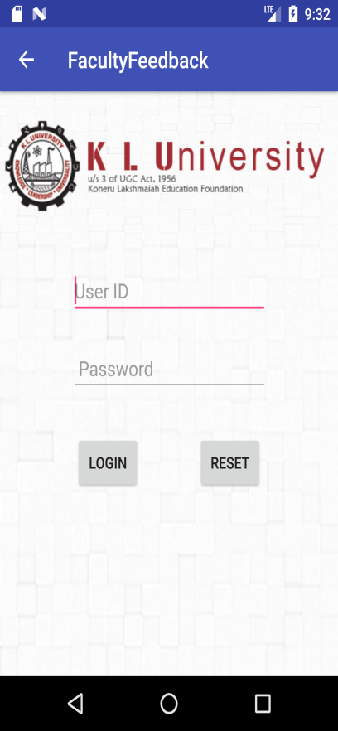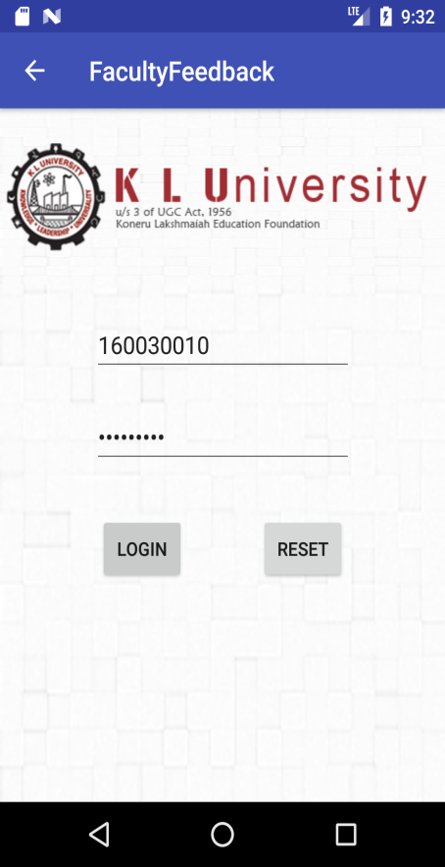

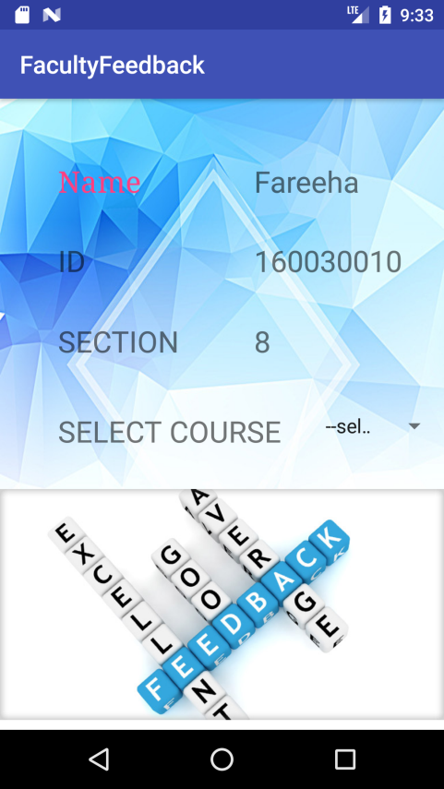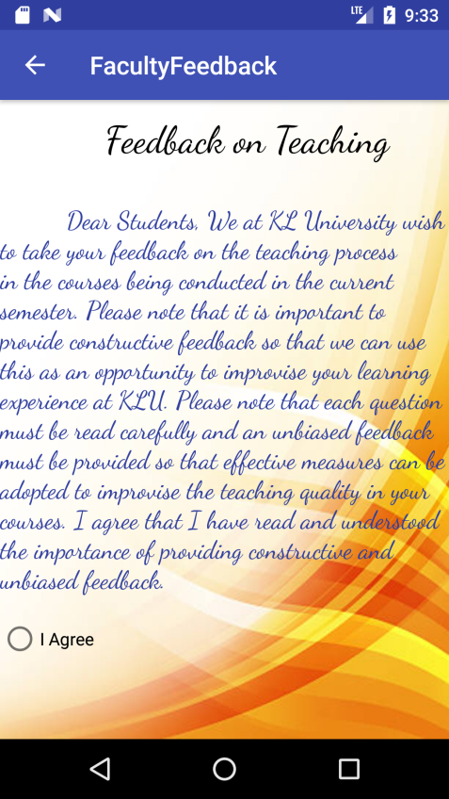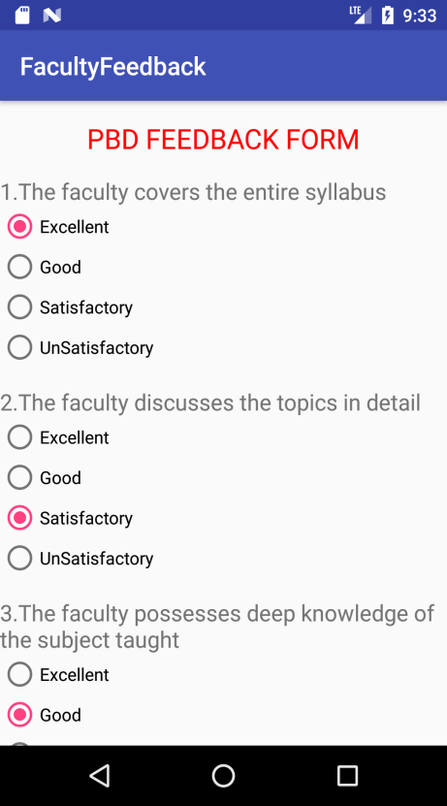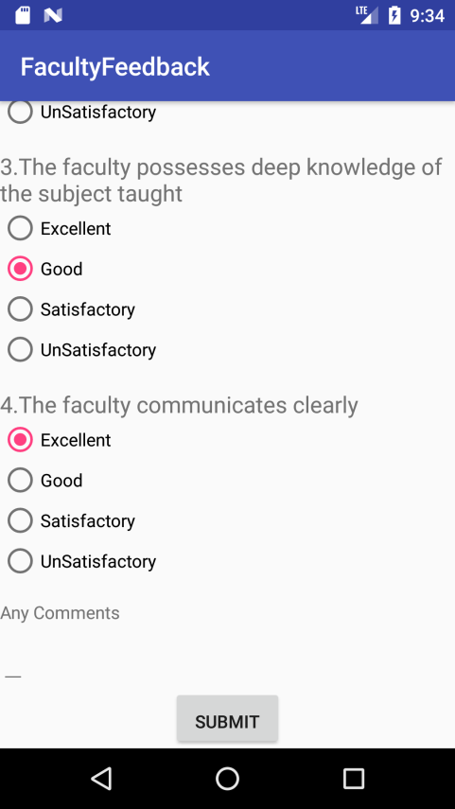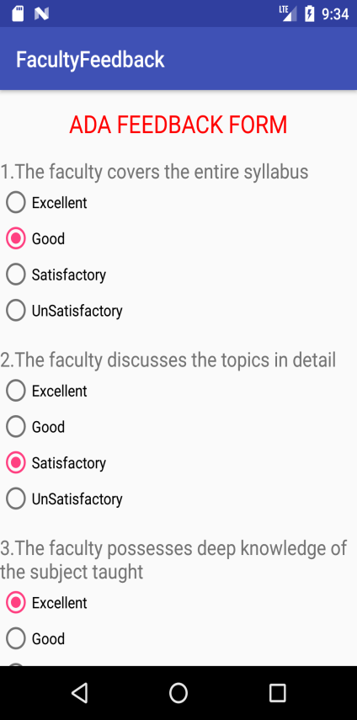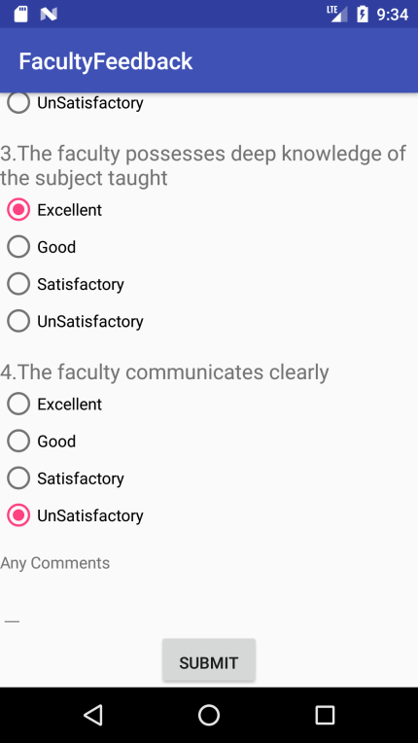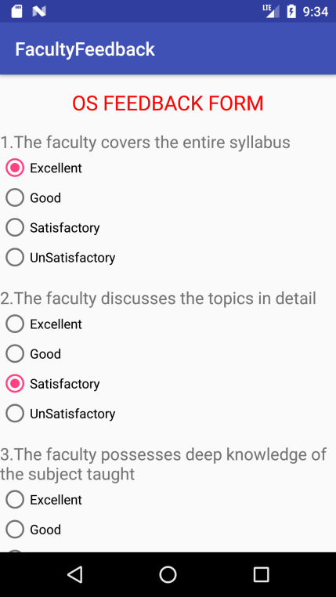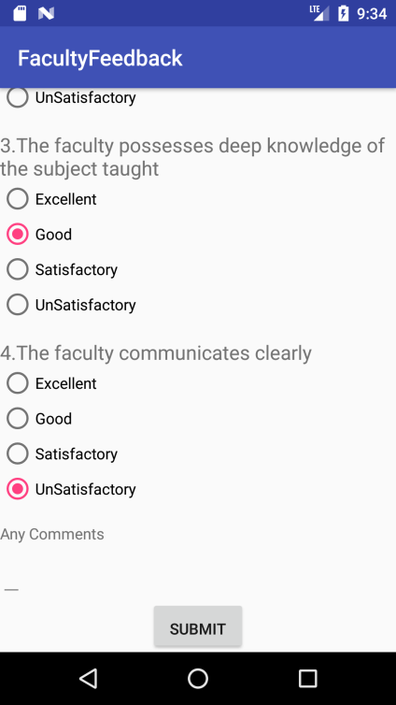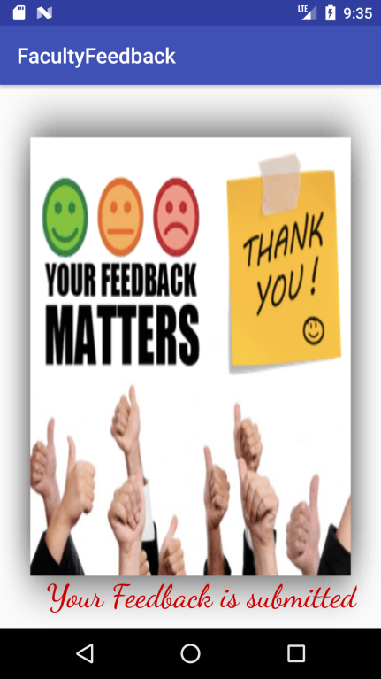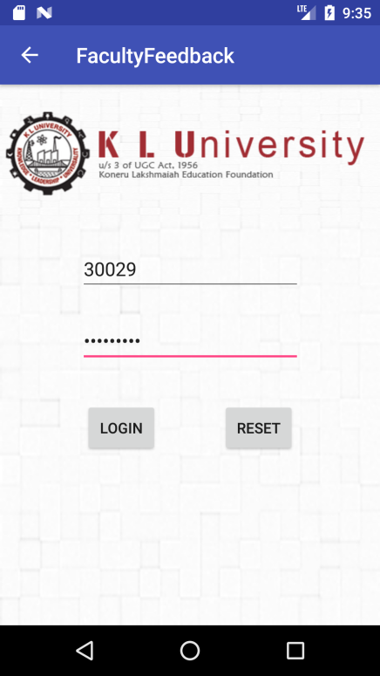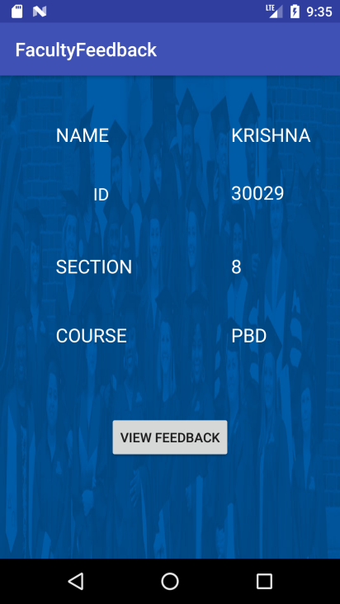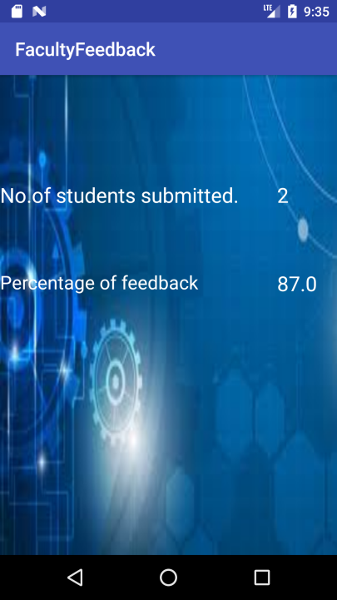

**CONCLUSION**

From all the above modules we can conclude that we can create Bill for water tax for the registered customer .We can add new customers to the Data base. We can search for customer in data base and all the details of customers are safe with user name and password of clerk. Hence we can conclude that Project is accomplished successfully.

**References:**

**Any website**

**Any text book**

**Any other source**